


app user guide

Contents
Getting Started 2
Opening the App 2
Logging in (first time only) 2
Option A: Group & Participant Codes 2
Option B: Scan a QR Code 3
Consent and Permissions 3
Using the Inspiring Futures Digital Journal 4
Write Entry 4
Take Photo 5
Record Video 5
Add From Phone 5
Record Audio 6
Viewing Your Journal 6
Editing and Deleting Entries 7
Using the App to Fill In Questionnaires 8
Scale Questions 8
Open Questions 9
Support 9

Getting Started
The Inspiring Futures Digital Journal app is designed for use on smartphone or tablet. It can be downloaded for free from the app store on your phone.

Opening the App
Once downloaded, the app icon looks like this on the screen:


Tap it and the app will open – the first time you use it, it will go to a log-in screen.

Logging in (first time only)
The first time you use the app, you will need to log in. There are two options:

Option A: Group & Participant Codes
Your researcher or project leader will give you a Group code – a short combination of letters and numbers. Enter that in the box that says ‘Group code’. It will take you to a similar screen, asking you to enter your participant ID. This is a unique identifier specific to you, which your researcher or project lead will give you.
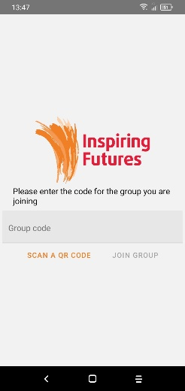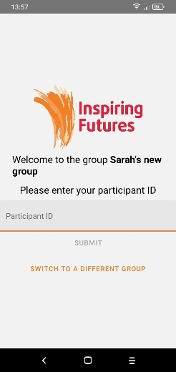
Tap in the box, and it will bring up the keyboard. Enter your unique ID (it is case sensitive so use capital letters where needed) then tap Submit.
Tap in the box, and it will bring up the keyboard. Enter the code, then tap Join Group.

On the next screen, click on Confirm Participation, and you will be logged in to the app.
Once you have logged in to the app, it will keep you logged in. We recommend you do not log out, as the research team will have to reset your account in order to log you back in.

Option B: Scan a QR Code
Your researcher or project lead might have a QR code for you to scan. If so, click “Scan a QR code” and follow the instructions.
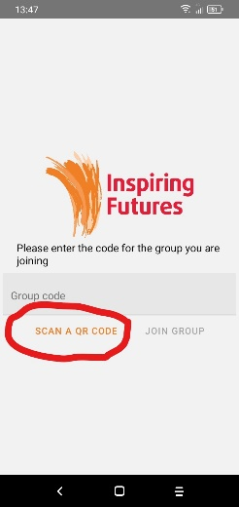
On the next screen, click on Confirm Participation, and you will be logged in to the app.
Once you have logged in to the app, it will keep you logged in. We recommend you do not log out, as the research team will have to reset your account in order to log you back in.

Consent and Permissions
When you initially log in, you may be asked to fill in a consent form before going any further. This tells you how we use your data, and confirms you’re happy to contribute to the research study.
The app might ask for permission to access your camera, microphone or storage, with a pop-up message. Click OK to this, and then it will ask you to clarify; click ‘Allow’. This won’t do anything else to your phone, it just means your camera and microphone work with the app, and your entries will be stored properly.
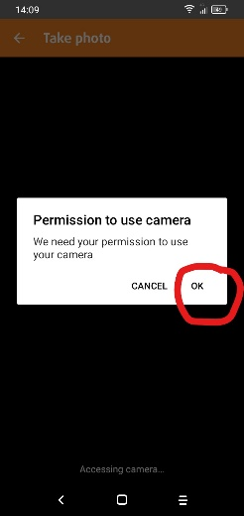

Using the Inspiring Futures Digital Journal
The app will open to the Home Page, which looks like this:
This has the list of all the options for adding something to your digital journal. If your screen is too small to show all the options (like this) then place your finger on the screen and slide it upwards, as if you are dragging the whole page towards the top of your phone. To select an option, click on the orange writing.

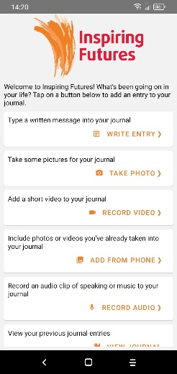
To choose an option, tap the orange writing – e.g. if you want to take a picture, tap on “Take Photo”.

Write Entry
If you click on “Write Entry” it will take you to a new screen where you can use the keypad to write in your entry. Once you have finished, click “Save” in the top right-hand corner, and it will be added to your journal and automatically uploaded to the research study server, for the researchers to see. You don’t have to do anything to make that happen.

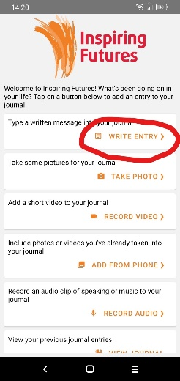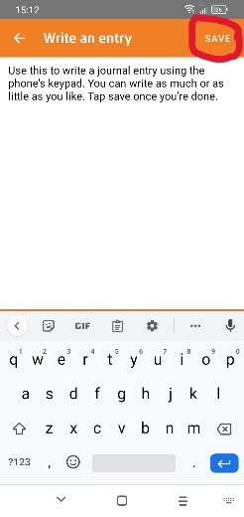

Take Photo
If you click on Take Photo, your camera will automatically open. Take a photo (the same way you normally would on your phone). The photo will appear with an option to add a caption, add more photos, or upload the photo:

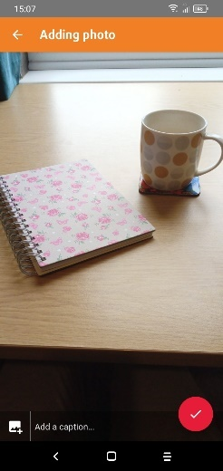
If you want to add a caption, tap here – it will bring up your phone’s keypad.
If you want more than one photo, tap the + icon – it will take you back to the camera. Carry on until you’re happy.
When you’re ready, click the red tick to upload your photo entry to your digital journal.

Record Video
This works the same as taking a photo, but you can record a video. Click the red button at the bottom to start recording, and the stop/pause button to stop. As with taking photos, there will be an option to add a caption if you would like to explain in text what your video is about. Once you’re ready, click the red tick button to add it to your journal.

Add From Phone
This feature enables you to use photos or videos that you have already taken on to your phone and add them to your Inspiring Futures journal. When you click Add From Phone, a screen will open with your phone’s Gallery. Click on the photo or video you would like to add. As above, it will give you the option of adding more entries or adding a caption. Once you’re happy, click the red tick to upload.

Record Audio
This allows you to add an audio recording to your digital journal. That might be a voice memo, or a recording of a song or poem you have written, or something you’re working on – we’d love to hear it! If you click “Record Audio” it will bring up a new screen. Click the red circle button to start your recording. Once you have finished, click the same button (which will have a red square now) and the recording will stop. If you have made a mistake and would like to restart, then click “Delete and Try Again”. If you are happy with it, click Save in the top right to add it to your journal.
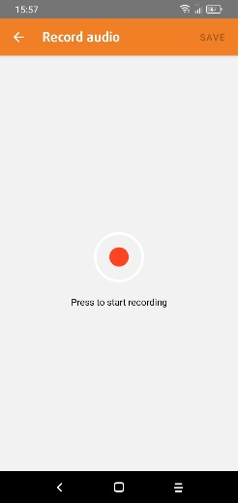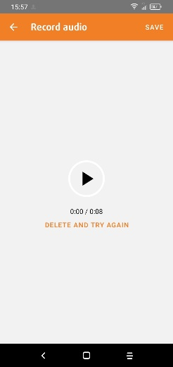
Tap the red button to start recording. It will turn into a red square; click this when you are finished.
Once you’re happy, click Save and it will be added to your journal.
If you’re not happy with the recording, click “Delete and Try Again”. If you’re asked ‘Are you sure?’ click on ‘Discard.’

Viewing Your Journal
To see what entries you already have in your journal, you can click on the “View Journal” button. You might need to move your screen up, which you can do by holding your finger down and moving it up the screen, as if you are dragging things upward:

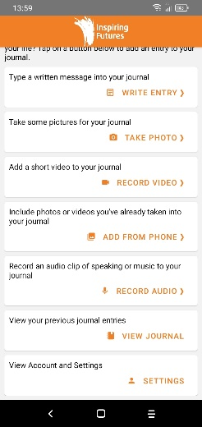
Clicking on “View Journal” will take you to your digital journal, where you can look back at previous entries.

The most recent entries will be at the top. If you’d like to see older ones, scroll down the page by pressing and holding your finger and moving it up the screen, as if you are dragging things upwards.

Editing and Deleting Entries
You can edit entries that you have made within the last 24 hours – for example, you can add/remove/change a photo or video caption, or change a written entry. You can also delete entries made in the last 24 hours, if you change your mind about them. To do this, press and hold for about two seconds on the white box around the entry. Once you take your finger off, it will be highlighted and two options will appear at the top for you to choose what you do.
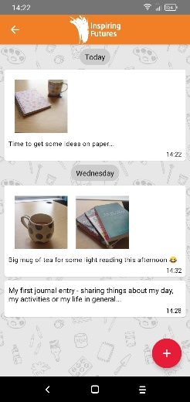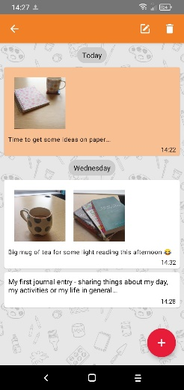
Press and hold for two seconds on the entry you want to edit. (You will only be able to do this within 24 hours of adding it.)
Tap here to delete your entry.
Tap here to edit your entry.

After 24 hours, you cannot edit or delete entries; if you want to remove some old items from your journal, you can press ‘hide’ which will take it off your phone. If you want the entry actually removed so it’s not used as part of the research study, then you will need to contact the research team.
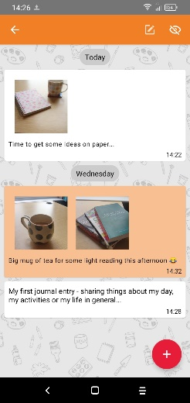
After 24 hours, you can tap here to ‘hide’ the entry, which means it won’t be on your phone any more.

Using the App to Fill In Questionnaires
At times, you might get a notification to say that there is a questionnaire to fill in. These are a part of the research study, helping us to see how arts activities are continuing to make a difference in people’s lives. Tap on the notification and it will take you to the questionnaire.
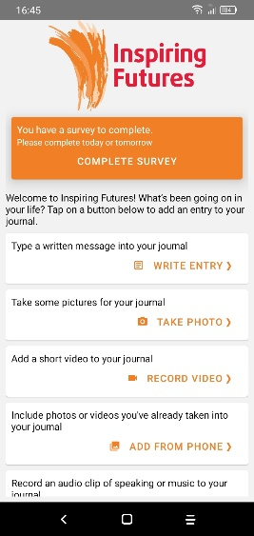
Tap on ‘Complete Survey’ and it will open the questionnaire. There is limited time to complete it; the deadline will be written in the notification.

The questionnaires cover several pages, so click ‘Next’ in the bottom right to go to the next page. There is a combination of yes/no questions, open questions, and statements with a scale of possible answers. As a general rule, tap in the appropriate box to answer a question. If you don’t want to answer one, you can simply miss it out.

Scale Questions
Most of the questions are statements with a scale of possible answers, from Strongly Agree to Strongly Disagree. For each question, tap in the appropriate box. For all questions, there is the option of hearing them spoken if you prefer that – click on the little logo by the side.
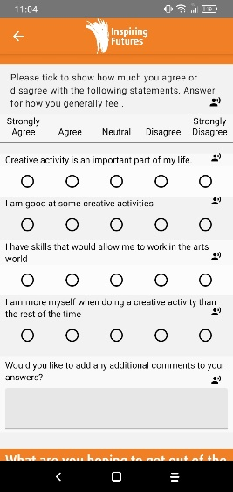
Whenever you see this symbol, you can tap it and it will read out the question or statement.
The “Strongly Agree” to “Strongly Disagree” columns will always be in the same place, so tap the circle in whichever column best represents your answer.

Open Questions
Some of the questions allow you to give comments or more detailed answers. For this, you can choose the option of how you answer, similar to how you can add entries to your digital journal. Tap the button, and then select the option you would like. We recommend you mostly use either a written entry or voice memo for these questions.
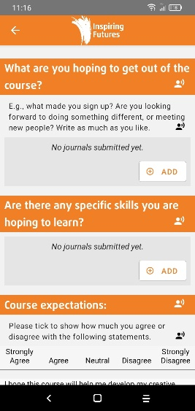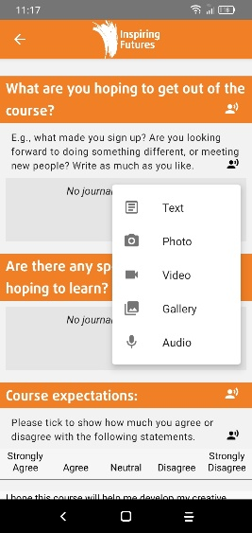
Tap the ‘Add’ button, and it will bring up a list of options (see right).
Tap the option you want, and follow the same instructions as adding to your journal.

Once you’ve completed the questionnaire, tap Submit, confirm submission, and then you’re done – it will automatically upload to our server. But please keep making entries to your digital journal after you’ve done the questionnaire.

Support
If you need any support with using your Inspiring Futures app, please contact the research team: you can email inspiringfutures@crim.cam.ac.uk or phone or text 07707 288282.

